**TELEFONICA**

**Novum**

**Service Specification**

**MinutesAllowance**

DOCUMENT INFORMATION

|  |  |
| --- | --- |
| **Document Author:** | Abhinav Saxena |
| **Owner while current:** | <owner name> |
| **Retention period:** | Novum Contract Duration |

CHANGE HISTORY

|  |  |  |  |
| --- | --- | --- | --- |
| **Version** | **Date** | **Changed by** | **Changes** |
| 0.1 | <date> | <author name> | Initial Draft |

RELATED DOCUMENTS

|  |  |  |  |
| --- | --- | --- | --- |
| **ID** | **Name** | **Version** | **Description** |
| 1 | <Myo2 service model name> | <version number> | MyO2 service model |

DESIGN LEAD SIGN-OFF

|  |  |  |  |
| --- | --- | --- | --- |
| **Name:** | Ajay Agarwal | | |
| **Role:** | Solution Architect | | |
| **APPROVED:** | YES NO | **Date:** |  |

DESIGN GOVERNANCE SIGN-OFF

|  |  |  |  |
| --- | --- | --- | --- |
| **Name:** | Hrishikesh Korde | | |
| **Role:** | Integration Architect | | |
| **APPROVED:** | YES NO | **Date:** |  |

ADDITIONAL APPROVAL SIGNATORIES

|  |  |  |  |
| --- | --- | --- | --- |
| **Name** | **Role** | **Approved** | **Date** |
| Graham Evans | Enterprise architect | YES NO |  |
| Adrian Koertzen | Delivery manager | YES NO |  |
| John Basevi | Integration architect | YES NO |  |

REVIEWERS

|  |  |  |  |
| --- | --- | --- | --- |
| **Name** | **Role** | **Approved** | **Date** |
| Chris Tarttelin | MyO2 Architect | YES NO |  |
| Anup Badve | Integration Delivery Lead | YES NO |  |

Contents

CHANGE HISTORY 2

RELATED DOCUMENTS 2

DESIGN LEAD SIGN-OFF 2

DESIGN GOVERNANCE SIGN-OFF 2

ADDITIONAL APPROVAL SIGNATORIES 2

REVIEWERS 2

1 Definitions and abbreviations 4

2 Introduction 5

2.1 Overview 5

2.2 Detailed Description 5

3 Consumer and Backend List 5

4 Service Policy 6

5 Resources Summary 6

5.1 API Connect API Gateway URIs 6

5.2 Backend URLs 6

6 Resource Definition 6

6.1 Error Messages 7

6.1.1 Technical Errors 8

7 Test Data Requirement 8

8 Risk, Issues, Assumptions, Dependencies 8

8.1 Assumptions 8

8.2 Risk 8

8.3 Issues / Open Points 8

8.4 Dependencies 8

# Definitions and abbreviations

|  |  |
| --- | --- |
| **Term** | **Definition** |
| API | Application Program Interface |
| HTTP | Hyper Text Transfer Protocol |
| HTTP/s | Hyper Text Transfer Protocol over TLS |
| TLS | Transport Layer Security |
| RESTful service | Representational State Transfer (REST) is a software architecture style that centres around the transmission of data over HTTP, using only the four basic HTTP verbs. |
| RPS | Request per second |

# Introduction

## Overview

The non-data allowances convert the SOA service response by filtering allowances that has unit as seconds and converting the values into the right format for the MyO2 app. There is also some static text added to the response for footer messages and thresholds.

The table embedded below details the following attributes of this API:

|  |  |  |
| --- | --- | --- |
| **Sno** | **Name** | **Value** |
| 1 | API name | MinutesAllowance |
| 2 | Consuming Applications | Novum |
| 3 | Backend Applications | PhoneService, SOA |
| 4 | Frontend protocol | https |
| 5 | Frontend data format | Get Request |
| 6 | Backend data format | JSON,SOAP |
| 7 | Backend protocol | https |
| 8 | Schema Validation | Yes |
| 9 | Payload Transformation | Yes |
| 10 | Header Transformation | No |
| 11 | Error mapping complexity | Medium |
| 12 | Average Response Time | <??> |
| 13 | Peak RPS | <??> |
| 14 | Max Daily Requests | <??> |
| 15 | Max Concurrent Transactions | <??> |
| 16 | API status | Active |
| 17 | Priority | Low/Medium/High |

## Detailed Description

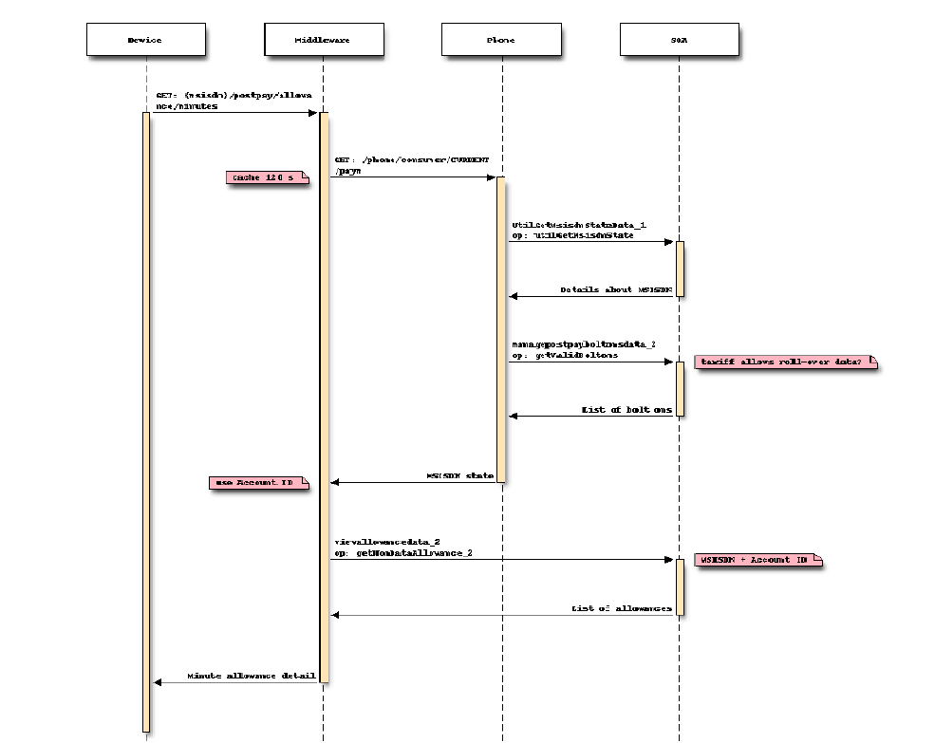

Figure 1 MinutesAllowance Flow

# Consumer and Backend List

List of consumer and Backend applications for this service:

|  |  |
| --- | --- |
| **Application Name** | **Consumer/Backend** |
| PhoneService, SOA | Backend |
| Novum | Consumer |

# Service Policy

Please note that the following volumes KPI are detailed in the API list embedded in section 2.1

* Response Time
* Peak RPS
* Max Daily Requests
* Max Concurrent Transactions

API Connect API gateway will support availability of 99.98% for each API exposed.

All APIs for Novum will not have a specific busy hour or operational window but the service should be available 24/7, 365 days/year.

# Resources Summary

## API Connect API Gateway URIs

The protocol to send a request to API Connect API gateway will be HTTP/S and REST.

The URI to access the resource is listed below:

|  |  |
| --- | --- |
| **Environment** | **URL** |
| Ref | https://34.247.139.35:9443/o2apic/sandbox/postpay/447521004675/allowance/minutes |
| Perf | https://<DNS>/<uri path> |
| Live | https://<DNS>/<uri path> |

## Backend URLs

The protocol to send a request to Backend systems will be HTTPS.

|  |  |  |
| --- | --- | --- |
| **Sno** | **Environment** | **Backend URL (comma separated in case of multiple)** |
| 1 | Ref | <https://api0.ref.o2.co.uk/phone/consumer/CURRENT/paym>,  <https://sdpapi.ref.o2.co.uk/services/ViewAllowance_2_0> |
| 2 | Perf | ?? |
| 3 | Live | ?? |

# Resource Definition

**Header**: this is a standard header as defined in the API Connect API Gateway HLD. The mandatory field will be as belowthat identifies a unique transaction from the consumer application.

The below headers must be sent as part of each HTTP message to API Connect API Gateway. The API Connect API Gateway platform may return an HTTP header named “apicTransactionID” however this can be ignored.

|  |  |  |
| --- | --- | --- |
| **Sno** | **Headers** | **Description** |
| **1** | **x-user-id** | User id of the user. |
| **2** | **x-client-id** | The consuming application will generate it on APIC and embed in header to connect to APIC |
| **3** | **x-correlator** | e2e correlator ID |
| **4** | **x-device** | Android/Apple etc. |
| **5** | **x-authcode** | Header value from O2 APIGW |

**Body:** Refer to the Schema below:

<Insert the Open API(swagger) file of the API at this place>

Please note that the source of this schema is contractual, uploaded at O2 sharepoint location: <insert the location of Open API from O2 sharepoint>

**REQUEST:**

The request parameters are passed in path and headers for ‘GET’ requests

|  |  |  |  |  |
| --- | --- | --- | --- | --- |
| **Locale** | **Parameter Name** | **Required** | **Type** | **Description** |
| Path | msisdn | Yes | String | msisdn |
| HTTP header | x-authcode | Yes | String | Contain an auth string |

Table 1 MinutesAllowance Request

An example of this object is shown below.

GET: /447521004675/postpay/allowance/minutes

**RESPONSE:**

The response data is returned as an object

|  |  |  |  |
| --- | --- | --- | --- |
| **Parameter Name** | **Required** | **Type** | **Description** |
| apicTransactionID | Yes | String | Unique ID of the transaction |

Table 2 MinutesAllowance response

An example of this object is shown below.

|  |
| --- |
| {  "footerMessage": "string",  "allowanceFooterMessage": "string",  "thresholdPercentage": 0,  "allowances": [  {  "startingBalance": 0,  "allowanceUsed": 0,  "allowanceRemaining": 0,  "percentAllowanceUsed": 0,  "expiryDate": "2018-06-23",  "description": "string",  "restrictionCategory": "string",  "unlimited": true,  "restricted": true  }  ]  } |

## Error Messages

In case of error, the *<API error response object name>* object will be returned.

The *errorResponse* object contains an error code and an error message, and is a JSON object having the following fields:

|  |  |  |  |
| --- | --- | --- | --- |
| Name | Description | Type | Mandatory |
| httpCode | HTTP status code of error | String | Yes |
| httpMessage | HTTP status message for error | String | Yes |
| moreInformation | Additional information describing the error | String | Yes |

**Table 3 Error Response**

An example of this object is shown below.

|  |
| --- |
| {"httpCode": "400",  "httpMessage": "Invalid request",  "moreInformation": "Missing or invalid msisdn"  } |

These are possible errors returned:

|  |  |
| --- | --- |
| **HTTP Code** | **HTTP message** |
| 400 | Invalid request |
| 401 | Unauthorized |
| 404 | Not Found |
| 405 | Method Not Allowed |
| 500 | Internal Server Error |

**Table 4 Error Table\***

*Note: The above table will be updated in due course of time

## Technical Errors

This section will be updated in due course of time, when consumer error mapping requirements are formally communicated.

# Test Data Requirement

Test data will be provided upon request.

# Risk, Issues, Assumptions, Dependencies

## Assumptions

|  |  |  |  |
| --- | --- | --- | --- |
| **Assumption ID** | **Description** | **Owner** | **Status** |
|  |  |  | Open |

## Risk

|  |  |  |  |
| --- | --- | --- | --- |
| **Risk ID** | **Description** | **Owner** | **Status** |
|  |  |  |  |

## Issues / Open Points

|  |  |  |  |
| --- | --- | --- | --- |
| **Issue ID** | **Description** | **Owner** | **Status** |
|  |  |  |  |

## Dependencies

|  |  |  |  |
| --- | --- | --- | --- |
| **Dependency ID** | **Description** | **Owner** | **Status** |
|  |  |  |  |
|  |  |  |  |